Caching in Node.js + Express
Caching in a Node.js + Express project means storing frequently requested data temporarily so that your application can return it faster instead of repeatedly querying the database or calling external APIs.
For example, if 100 users request the same list of products, instead of querying MongoDB 100 times, you can query the database once and serve the cached result to the next 99 users.

1. Types of caching in Node.js Express
There are several caching approaches:
Type | Description | Best for
In-memory cache | Stores data in Node.js memory | Small applications
Redis cache | Stores data in a separate Redis server | Production applications
HTTP caching | Uses browser/proxy cache headers | Static and public API responses
Database caching | Caches frequently executed database queries | Database-heavy applications

2. In-memory caching using node-cache
Beginner-friendly
Node-cache is a simple package that stores data in your application's memory.
Step 1: Install the package
npm install node-cache
Step 2: Create a cache instance
Create a file called config/cache.js:
const NodeCache = require('node-cache');
const cache = new NodeCache({
stdTTL: 60, // Default expiration: 60 seconds
checkperiod: 120 // Check expired keys every 120 seconds
});
module.exports = cache;
Step 3: Create a products route
Imagine that you have a MongoDB collection containing products.
routes/productRoutes.js:
const express = require('express');
const router = express.Router();
const cache = require('../config/cache');
const Product = require('../models/Product');
// GET all products
router.get('/', async (req, res) => {
try {
// 1. Check whether products exist in cache
const cachedProducts = cache.get('products');
if (cachedProducts) {
console.log('Data from CACHE');
return res.json({ source: 'cache', data: cachedProducts });
}
// 2. If not cached, query MongoDB
console.log('Data from DATABASE');
const products = await Product.find();
// 3. Store results in cache for 60 seconds
cache.set('products', products);
// 4. Return products
return res.json({ source: 'database', data: products });
} catch (error) {
return res.status(500).json({ message: error.message });
}
});
module.exports = router;
Step 4: Register the route
app.js:
const express = require('express');
const app = express();
const productRoutes = require('./routes/productRoutes');
app.use(express.json());
app.use('/api/products', productRoutes);
app.listen(3000, () => {
console.log('Server running on port 3000');
});

3. How does it work?
Let's imagine you send three requests to:
GET http://localhost:3000/api/products
First request: CACHE MISS
Client Request → Check Cache → Not Found → MongoDB Query → Save Result in Cache → Return Response
Second request: CACHE HIT
Client Request → Check Cache → Found → Return Cached Data
Third request: CACHE HIT
Returns cached data without querying MongoDB.
After 60 seconds, the cached entry expires. The next request queries MongoDB again.

4. Cache invalidation (Very Important!)
One of the biggest challenges in caching is keeping cached data synchronized with the database.
For example:
- You request all products.
- The products are stored in cache.
- You add a new product.
- You request all products again.
- The cache might return the old products without the newly added product.
Solution: Clear the cache whenever you modify the products.
For example, in your POST route:
router.post('/', async (req, res) => {
try {
const product = await Product.create(req.body);
// Clear cached products
cache.del('products');
res.status(201).json(product);
} catch (error) {
res.status(500).json({ message: error.message });
}
});
Apply the same idea to update and delete operations.
Useful Node-cache methods
Method | Description
cache.set(key, value) | Store data
cache.get(key) | Retrieve data
cache.del(key) | Delete specific cached data
cache.has(key) | Check whether key exists
cache.flushAll() | Delete all cached data
cache.ttl(key, seconds) | Change expiration time

5. Redis caching (Production approach)
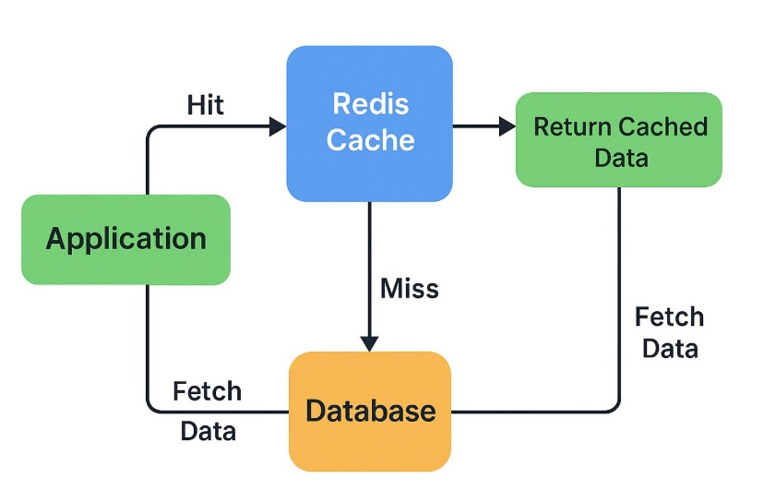
Intermediate / Advanced
For larger applications, Redis is often a better solution than in-memory caching.
Why?
- Redis runs separately from your Node.js application.
- Multiple Node.js instances can share the same cache.
- Cached data can survive application restarts, depending on Redis persistence configuration.
- Redis supports expiration times (TTL).
- It supports different data structures.
Install Redis client
npm install redis
Create config/redis.js
const { createClient } = require('redis');
const redisClient = createClient({
url: 'redis://localhost:6379'
});
redisClient.on('error', (err) => {
console.error('Redis Error:', err);
});
async function connectRedis() {
await redisClient.connect();
console.log('Redis connected successfully');
}
module.exports = { redisClient, connectRedis };
Connect Redis in app.js
const express = require('express');
const { connectRedis } = require('./config/redis');
const app = express();
async function startServer() {
await connectRedis();
app.listen(3000, () => {
console.log('Server running on port 3000');
});
}
startServer();
Using Redis in a products route
const express = require('express');
const router = express.Router();
const { redisClient } = require('../config/redis');
const Product = require('../models/Product');
router.get('/', async (req, res) => {
try {
// Check Redis
const cachedProducts = await redisClient.get('products');
if (cachedProducts) {
return res.json({ source: 'redis', data: JSON.parse(cachedProducts) });
}
// Query MongoDB
const products = await Product.find().lean();
// Store in Redis for 60 seconds
await redisClient.set('products', JSON.stringify(products), { EX: 60 });
res.json({ source: 'database', data: products });
} catch (error) {
res.status(500).json({ message: error.message });
}
});
module.exports = router;

6. In-memory vs Redis

Feature | Node-cache | Redis
Installation | npm package | Separate Redis server
Storage | Application memory | Redis server memory
Speed | Very fast | Very fast
Shared between servers | No | Yes
Persistence | No | Configurable
TTL | Yes | Yes
Complexity | Easy | Moderate
Production suitability | Small/single-instance apps | Distributed applications

